ECSE 4810/6810 Fall, 2022

Project 1

**BN inference with Belief Propagation**

Due 11:59 pm, 10/14, 2022

In this project, you will implement the belief propagation algorithms for posterior probability and most probable explanation (MPE) inference for the Bayesian Network given below, where each node is binary, assuming a value of 1 or 0 and CPT for each node is given.

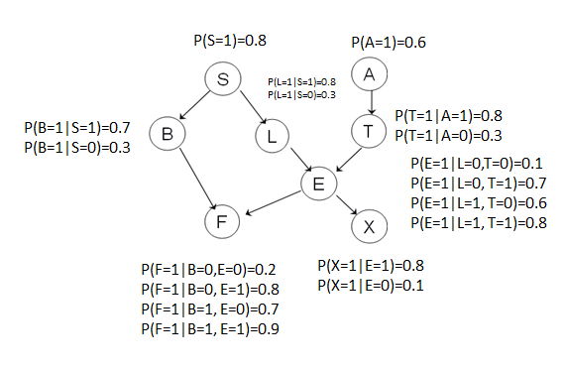

Given the BN and its parameterization,

1. implement the marginal posterior probability (sum-product) inference algorithm using a programming language of your choice (preferably Python or Matlab) to compute p(Xq| L=1, X=0), where Xq{S,A,B,T,E,F}
2. Implement the MPE (max-product) inference algorithm to compute (only for 6000 level students)

s*, a*, b* t* e* f* = arg max s,a,b,t,e,f p(s,a,b,t,e,f| L=1, X=0)

Submit the following

1. A report that includes the following
2. An introduction that discusses the purpose of BN inference and different types of BN inference, including the posterior probability inference and MPE inference.
3. A theory section that discusses belief propagation algorithms for posterior probability and MPE inferences, including their theories, key equations, and pseudocode for each method.
4. An experimental result section that summarizes the posterior probability inference results for each **x**q, and the MPE inference result.
5. Conclusion-a summary of the tasks you perform, issues encountered, and what you have learned.
6. A well-documented source code, including instructions on how to run your code to perform the required inferences.

1. A zip file that packages your report, source code, and other related materials. Name the zip file in the format: PGM_Proj1_Fall22_xxx, where xxx is your last and first name.

Deposit the zip file in your box folder before the deadline.

Your project will be evaluated based on the following criteria:

1. Report (40%)-the report should be professionally written, with introduction,

problem statement, theory, experiments, conclusion, and related references if applicable. All figures and tables (if any) should be clearly numbered and cited, with proper captions.

1. Results (40%) – correctness of the inference results for the required inferences, including both the self-reported results and the results we generate.
2. Code (20%) – document your code adequately. For each function, clearly define its variables, write down its purpose, and identify its input and output arguments.